**Project On Sentiment Analyzer**

Contents

* Preface
* Team members
* About project
* Target audience
* Algorithm used
* Source code
* Screen shots
* Summary
* Source of information
* Google Drive link

Preface

* The aim of the project is about analyzing the emotions of the people i.e. how people “feel” about something.
* By knowing this, companies and brands can leverage the information to alter their communication strategy or to recognize events that may need to be addressed before it becomes a full blown crisis.

About Team Members

* Paras (Group leader):05013302715
* Akash garg:00613302715
* Dev Gupta:02313302715
* Mehul Garg:04313302715

About Project

* Sentiment analysis is simply understanding how people feel about a particular thing.
* It involves the task of automatically classifying a text written in a natural language into a positive or negative feeling, opinion or subjectivity.
* In this project we are using the technique of speech to text conversion.
* The text that is recorded from the mic is stored in the text file and over this the terms of the algorithm is applied to spread their polarity, properly combining the values of morphological category of the word and the relation that affect them.
* We have taken a datasets of possible English words having there negative and positive POS tags from the dataset present in the “vader Sentiments” modules where all the words have their respective positive and negative counts stored in a text file
* In addition to the polarity of the text, the machine returns polarity for word groups in 4 possible levels: positive (pos), negative (neg), neutral (neu) and compound.

Target audience

* It can be used by companies in various ways, capitalize on things that seem to be creating more specific buzz within their audience.
* How do your customers feel about your brand?
* Opinion about your brand against competitors.
* Latest trends related to your brand.
* It helps in sighting into how your marketing and communication strategy should be modified.
* In many social networking services or e-commerce websites, users can provide text review, comment or feedback to the items.

Algorithms used

* NLTK(speech recognition): The **Natural Language Toolkit**, or more commonly **NLTK**, is a suite of [libraries](https://en.wikipedia.org/wiki/Library_(computer_science)) and programs for symbolic and statistical [natural language processing](https://en.wikipedia.org/wiki/Natural_language_processing) (NLP) for English written in the [Python programming language](https://en.wikipedia.org/wiki/Python_(programming_language)).
* Training and Testing of data: In many areas of [information science](https://en.wikipedia.org/wiki/Information_science), finding predictive relationships from [data](https://en.wikipedia.org/wiki/Data) is a very important task. The initial discovery of relationships is usually done with a **training set**, while a **test set** and **validation set** are used for evaluating whether the discovered relationships hold.
* A *training set* is a set of [data](https://en.wikipedia.org/wiki/Data) used to discover potentially predictive relationships.
* A *test set* is a set of [data](https://en.wikipedia.org/wiki/Data) used to assess the strength and utility of a predictive relationship.
* Neural networking (naive-Bayes): **Artificial neural networks** (**ANNs**), a form of [**connectionism**](https://en.wikipedia.org/wiki/Connectionism), are computing systems inspired by the [biological neural networks](https://en.wikipedia.org/wiki/Biological_neural_network) that constitute animal brains. Such systems learn (progressively improve performance) to do tasks by considering examples, generally without task-specific programming.

* Vader Sentiment (python tool): *VADER Sentiment Analysis. VADER (Valence Aware Dictionary and sentiment Reasoner) is a lexicon and rule-based sentiment analysis tool that is specifically attuned to sentiments expressed in social media, and works well on texts from other domains.*
* Flask (web framework): **Flask** is a micro framework written in [Python](https://en.wikipedia.org/wiki/Python_(programming_language)) and based on the Werkzeug toolkit and [Jinja2](https://en.wikipedia.org/wiki/Jinja_(template_engine))template engine. It is [BSD licensed](https://en.wikipedia.org/wiki/BSD_licenses).
* The latest stable version of Flask is 0.12 as of December 2016. Applications that use the Flask framework include Pinterest, LinkedIn, and the community web page for Flask itself.
* Flask is called a micro framework because it does not require particular tools or libraries.
* It has no database abstraction layer, form validation, or any other components where pre-existing third-party libraries provide common functions.
* Google api for speech recognition: Google Cloud Speech API enables developers to convert audio to text by applying powerful neural network models in an easy to use API. The API recognizes over 110 languages and variants, to support your global user base. You can transcribe the text of users dictating to an application’s microphone, enable command-and-control through voice, or transcribe audio files, among many other use cases.

Source code

Python source code:

import speech_recognition as sr

from vaderSentiment.vaderSentiment import SentimentIntensityAnalyzer

from flask import Flask, render_template

app = Flask(__name__)

@app.route('/')

def index():

return render_template('template.html')

@app.route('/my-link/')

def my_link():

r = sr.Recognizer()

with sr.Microphone() as source:

print("Say something!")

audio = r.listen(source)

with open("speech data.txt","r+") as myfile:

myfile.truncate()

myfile.write(r.recognize_google(audio))

analyzer=SentimentIntensityAnalyzer()

f=open('speech data.txt','r')

for sentence in f:

vs=analyzer.polarity_scores(sentence)

a="{:-<100} {}".format(sentence,str(vs))

return render_template('output2.html',value=a)

if __name__ == '__main__':

app.run(debug=True)

HTML source code:

Code for Home page:

<html>

<head>

<link rel="stylesheet" href="style/style.css" />

<link rel="icon" href="img/favicon.ico">

<link rel="shortcut icon" href="img/favicon.ico" />

</head>

<body>

<div class="container">

<div class="header-bar">

<div class="header-logo">

<center>

<a href="#">SENTIMENT ANALYSER</a>

</center>

</div>

<div class="header-links">

<center>

<a href="#">EXIT</a>

</center>

</div>

<div class="header-links">

<center>

<a href="#">WELCOME</a>

</center>

</div>

</div>

<div class="body-content" >

<CENTER>

<div class="asd"><img src="1.jpg" width=600 height=270 alt="logo"></div>

<a href="http://localhost:5000/my-link/"><a href="process.html"><div class="asd"><img src="mic2.gif" width=100 height=150 alt="logo"></div></a>

<!--<H2><input type="button" id="readMore" class="readButton" value="START" />--></a>

</CENTER>

</div>

</div>

<center>

<footer id="footer" class="text-center">

<div class="container">

<div class="row">

<div class="col-lg-12">

<div class="footer-logo wow fadeInDown">

<img src="cartoon.gif" width=200 height=150 alt="logo">

</div>

<div class="footer-social wow fadeInUp">

<h3>We are social</h3>

</div>

<div class="copyright">

<p>Theme by <a href="#"></a> Developed by <a href="my.html">LAZY BOYZ</a></p>

</div>

</div>

</div>

</div>

</footer></center>

</body>

</html>

Code for Listening window

<html>

<head>

<link rel="stylesheet" href="style/style.css" />

<link rel="icon" href="img/favicon.ico">

<link rel="shortcut icon" href="img/favicon.ico" />

</head>

<body>

<div class="container">

<div class="header-bar">

<div class="header-logo">

<center>

<a href="#">SENTIMENT ANALYSER</a>

</center>

</div>

</div>

<div class="body-content" >

<CENTER>

<!---<div class="asd2"><img src="pr.GIF" width=300 height=200 alt="PROCESSING"></div>-->

<div class="asd2"><img src="pr3.GIF" width=300 height=200 alt="PROCESSING"></div>

<a href="http://localhost:5000/my-link/"><H2><input type="button" id="readMore" class="readButton" value="LISTEN" /></a>

</CENTER>

</div>

</div>

<center>

<footer id="footer" class="text-center">

<div class="container">

<div class="row">

<div class="col-lg-12">

<div class="copyright">

<p><a href="my.html"></a> <a target="my.php"></a></p>

</div>

</div>

</div>

</div>

</footer></center>

</body>

</html>

Output window:

<html>

<head>

<link rel="stylesheet" href="style/style.css" />

<link rel="icon" href="img/favicon.ico">

<link rel="shortcut icon" href="img/favicon.ico" />

</head>

<body>

<div class="container">

<div class="header-bar">

<div class="header-logo">

<center>

<a href="#">SENTIMENT ANALYSER</a>

</center>

</div>

</div>

<center>

<div class="mypage"><h2><H1>&nbsp &nbsp OUTPUT IS </HR>

<p>{{value}}

</p>

</h2>

</div>

</center>

</DIV>

<center>

<footer id="footer" class="text-center">

<div class="container">

<div class="row">

<div class="col-lg-12">

<div class="copyright">

<p>Theme by <a href="my.html">LAZY BOYS</a> Developed by <a target="my.php">LAZY BOYS</a></p>

</div>

</div>

</div>

</div>

</footer></center>

</body>

</html>

SCREENSHOTS

Home page:

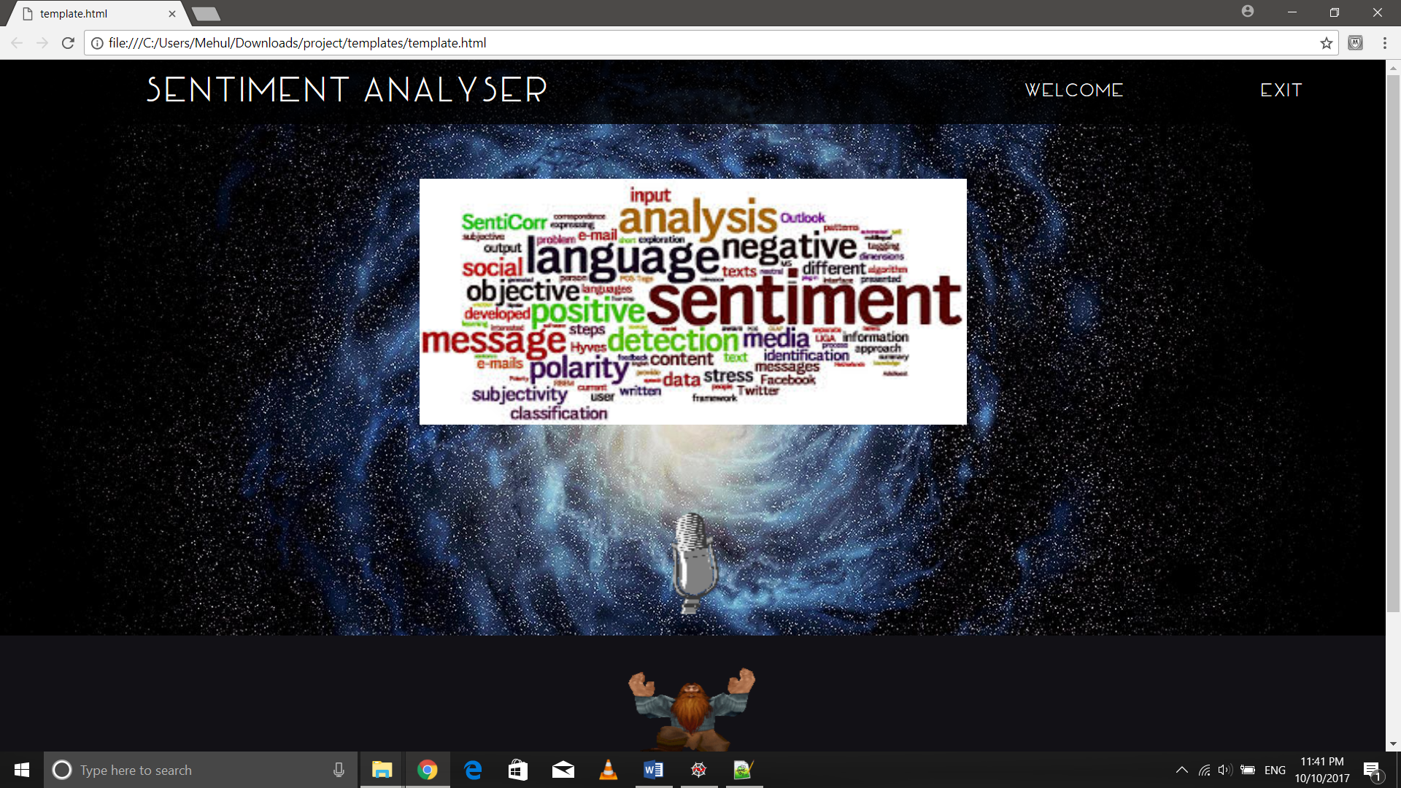

Listening page:

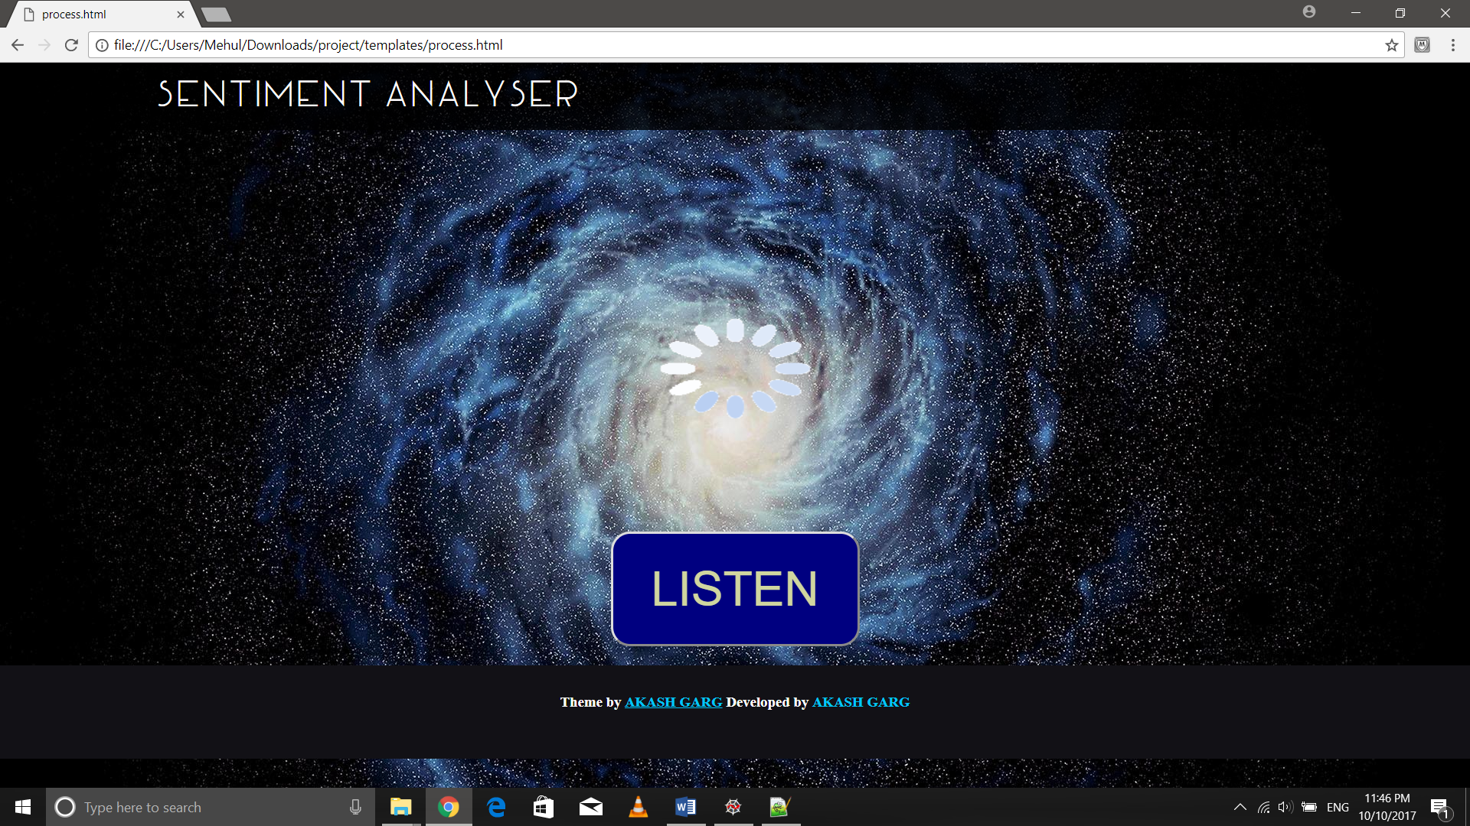

Output page:

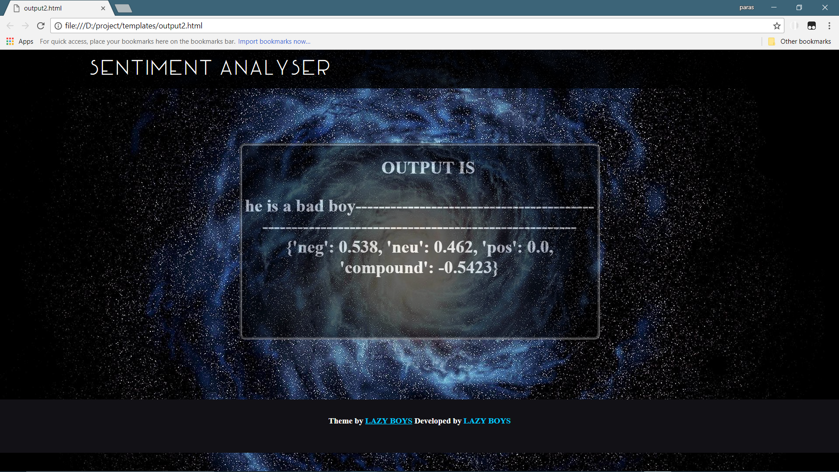

Python console window:

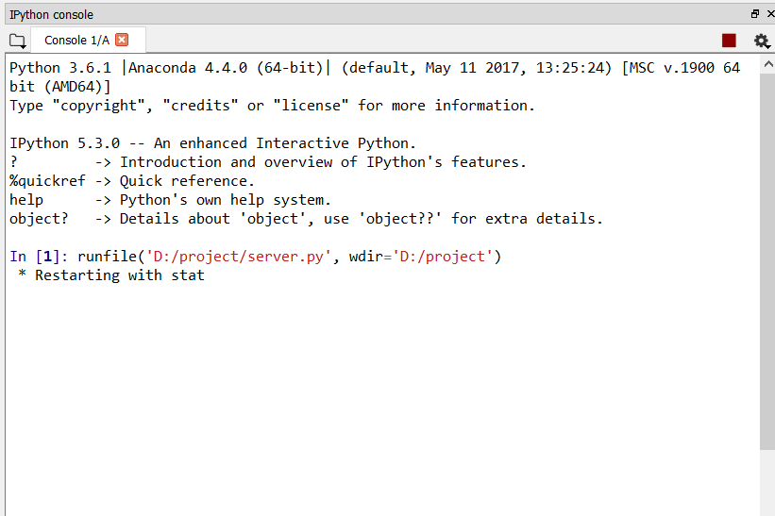

Excel file

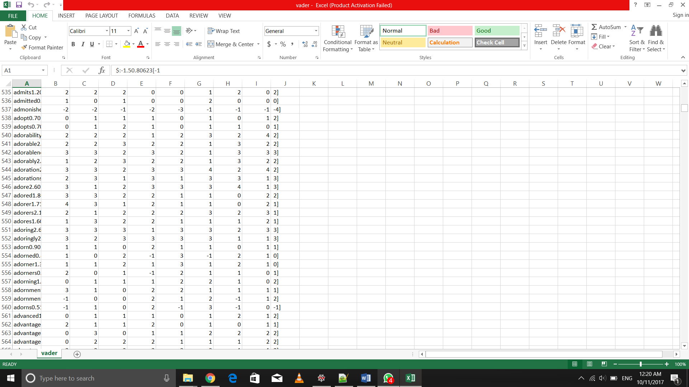

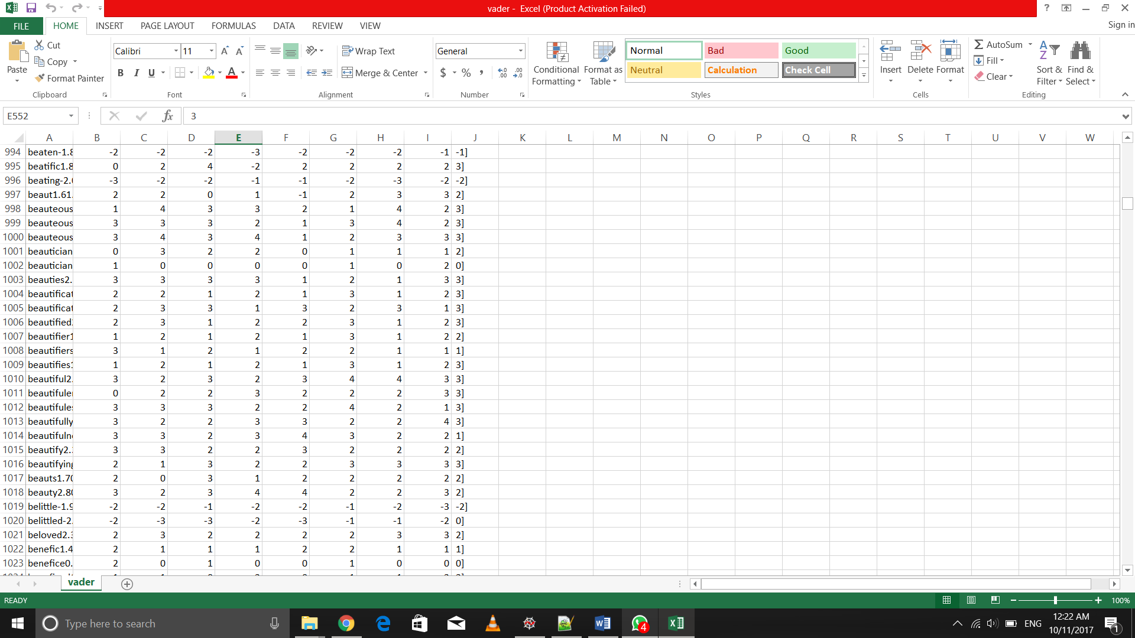

The excel file contains approximately the whole English vocabulary and emoji symbols.

Summary

**Sentiment analysis** (sometimes known as **opinion mining** or **emotion AI**) refers to the use of [natural language processing](https://en.wikipedia.org/wiki/Natural_language_processing), [text analysis](https://en.wikipedia.org/wiki/Text_analytics), [computational linguistics](https://en.wikipedia.org/wiki/Computational_linguistics), and [biometrics](https://en.wikipedia.org/wiki/Biometrics) to systematically identify, extract, quantify, and study affective states and subjective information. Sentiment analysis is widely applied to [voice of the customer](https://en.wikipedia.org/wiki/Voice_of_the_customer) materials such as reviews and survey responses, online and social media, and healthcare materials for applications that range from [marketing](https://en.wikipedia.org/wiki/Marketing) to [customer service](https://en.wikipedia.org/wiki/Customer_relationship_management) to clinical medicine.

A basic task in sentiment analysis is classifying the *polarity* of a given text at the document, sentence, or feature/aspect level—whether the expressed opinion in a document, a sentence or an entity feature/aspect is positive, negative, or neutral. Advanced, "beyond polarity" sentiment classification looks, for instance, at emotional states such as "angry", "sad", and "happy".

The accuracy of a sentiment analysis system is, in principle, how well it agrees with human judgments. This is usually measured by variant measures based on [precision and recall](https://en.wikipedia.org/wiki/Precision_and_recall) over the two target categories of negative and positive texts. However, according to research human raters typically only agree about 80%of the time .

For a [recommender system](https://en.wikipedia.org/wiki/Recommender_system), sentiment analysis has been proven to be a valuable technique. A [recommender system](https://en.wikipedia.org/wiki/Recommender_system) aims to predict the preference to an item of a target user. Mainstream recommender systems work on explicit data set. For example, [collaborative filtering](https://en.wikipedia.org/wiki/Collaborative_filtering) works on the rating matrix, and [content-based filtering](https://en.wikipedia.org/wiki/Content-based_filtering) works on the [meta-data](https://en.wikipedia.org/wiki/Metadata) of the items.

We have taken a datasets of possible English words having there negative and positive POS tags from the dataset present in the “vader Sentiments” modules where all the words have their respective positive and negative counts stored in a text file

In addition to the polarity of the text, the machine returns polarity for word groups in 4 possible levels: positive (pos), negative (neg), neutral (neu) and compound.

Source of information

* <https://cloud.google.com/speech/>
* <https://docs.python.org/3/>
* <https://github.com/cjhutto/vaderSentiment>
* <https://en.wikipedia.org/wiki/>
* <https://www.google.co.in/>

Google Drive Shareable link

The shareable google drive link for our project is given below:

https://drive.google.com/folderview?id=0B3gPUBqopTcASTZBVHJySlN1Q2c